INTRODUCTION TO SOFTWARE ENGINEERING
Lecture Notes
CHAPTER 3
Software Process Models
Topics: Waterfall • Incremental • Spiral • Agile • Scrum • XP • Model Comparison

Table of Contents
Chapter 3: Software Process Models 1
3.1 What is a Software Process Model? 1
3.2 The Waterfall Model 1
3.2.1 Phases of the Waterfall Model 1
3.2.2 Advantages of the Waterfall Model 1
3.2.3 Disadvantages of the Waterfall Model 1
3.3 The Incremental Model 1
3.3.1 Types of Incremental Development 1
3.3.2 Advantages of the Incremental Model 1
3.3.3 Disadvantages of the Incremental Model 1
3.4 The Spiral Model 1
3.4.1 The Four Quadrants 1
3.4.2 Advantages of the Spiral Model 1
3.4.3 Disadvantages of the Spiral Model 1
3.5 Agile Software Development 1
3.5.1 Scrum 1
Scrum Roles 1
Scrum Artefacts 1
Scrum Ceremonies (Events) 1
Sprints 1
3.5.2 Extreme Programming (XP) 1
XP Core Values 1
XP Key Practices in Detail 1
3.6 Comparison of Software Process Models 1
Selecting the Right Model — Decision Guide 1
Review Questions 1
Further Reading 1

Chapter 3: Software Process Models
A software process model is a simplified representation of a software process. Each model represents a process from a particular perspective and thus provides partial information about that process. These are abstract frameworks intended to guide software projects from conception to delivery.
This chapter explores the most widely used process models, including their structures, advantages, limitations, and appropriate application contexts.

3.1 What is a Software Process Model?
A software process model describes the organisation of a software development process. It defines:
- The activities that must be performed
- The order and dependencies between activities
- The roles and responsibilities of people involved
- The artefacts (documents, code, etc.) produced
- The criteria for moving from one stage to the next

Process models serve as blueprints for managing and guiding development. They help teams achieve predictability, repeatability, and quality in software delivery.

Key Concept: Why Process Models Matter?
Without a defined process model, software projects risk scope creep, schedule overruns, inconsistent quality, and poor team coordination. A well-chosen model aligns with the nature of the project, team size, and customer requirements to maximise the chance of project success.

Software process models can broadly be categorised into:
- Plan-driven (predictive) models – All process activities are planned in advance (e.g., Waterfall, Spiral)
- Agile (adaptive) models – Planning is incremental and the process adapts to changing requirements (e.g., Scrum, XP)
- Hybrid models – Combinations of plan-driven and agile approaches

3.2 The Waterfall Model
The Waterfall Model, introduced by Winston Royce in 1970, is the oldest and most classical software development lifecycle (SDLC) model. It is a linear sequential model in which development flows steadily downward — like a waterfall — through a series of defined phases.

3.2.1 Phases of the Waterfall Model
- Requirements Analysis – Gathering and documenting all requirements before development begins.
- System Design – Translating requirements into a system architecture and design specification.
- Implementation – Writing the actual code based on the design documents.
- Integration & Testing – Combining modules and verifying the system against requirements.
- Deployment – Releasing the product to end-users or the production environment.
- Maintenance – Ongoing bug fixes, updates, and enhancements post-deployment.

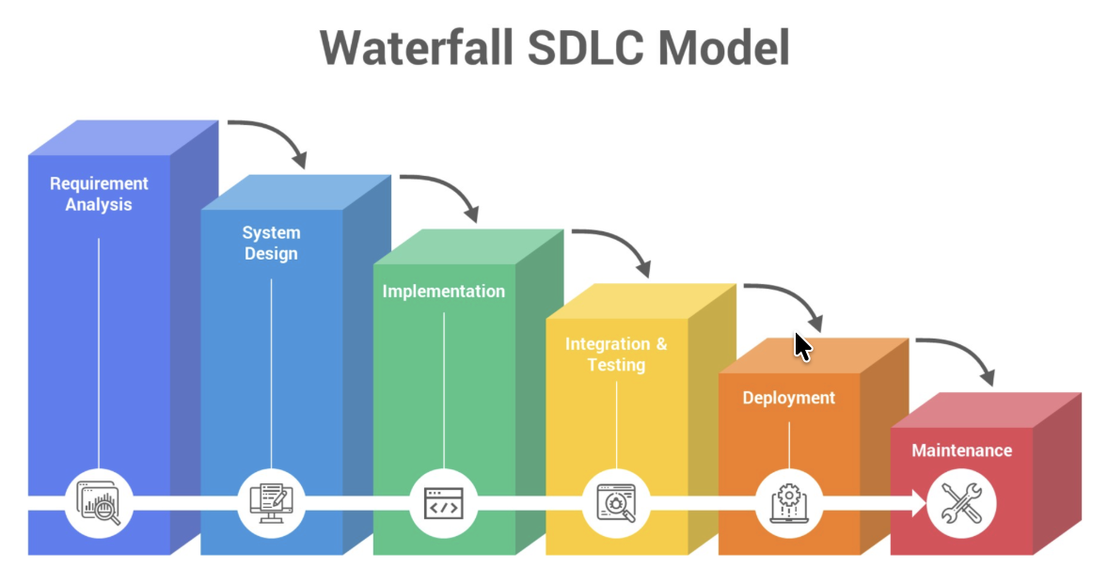
Figure 3.1: The Waterfall Model — Sequential phase progression with feedback loop

3.2.2 Advantages of the Waterfall Model
- Simple and easy to understand and manage
- Clearly defined stages with specific deliverables and review processes
- Works well for projects with very well-defined, stable requirements
- Easy to schedule milestones and measure progress
- Extensive documentation ensures knowledge transfer

3.2.3 Disadvantages of the Waterfall Model
- Very poor model for long, complex, or object-oriented projects
- High risk and uncertainty — no working software produced until late in the lifecycle
- Not suitable when requirements are unclear or likely to change
- Difficult and costly to go back to a previous phase once completed
- Customer only sees the product at the end, limiting feedback opportunities

When to Use the Waterfall Model
Best suited for: Short projects with clear, fixed requirements; embedded or safety-critical systems; projects with strict regulatory documentation requirements; situations where the technology is well understood by the team.

3.3 The Incremental Model
The Incremental Model combines elements of the waterfall model with an iterative philosophy. Instead of delivering the full system at once, the software is designed, implemented, and tested in increments — each adding new functionality on top of the previous working version.

The system is decomposed into components based on priority. The highest-priority functionality is delivered in the first increment, allowing stakeholders to begin using core features early.

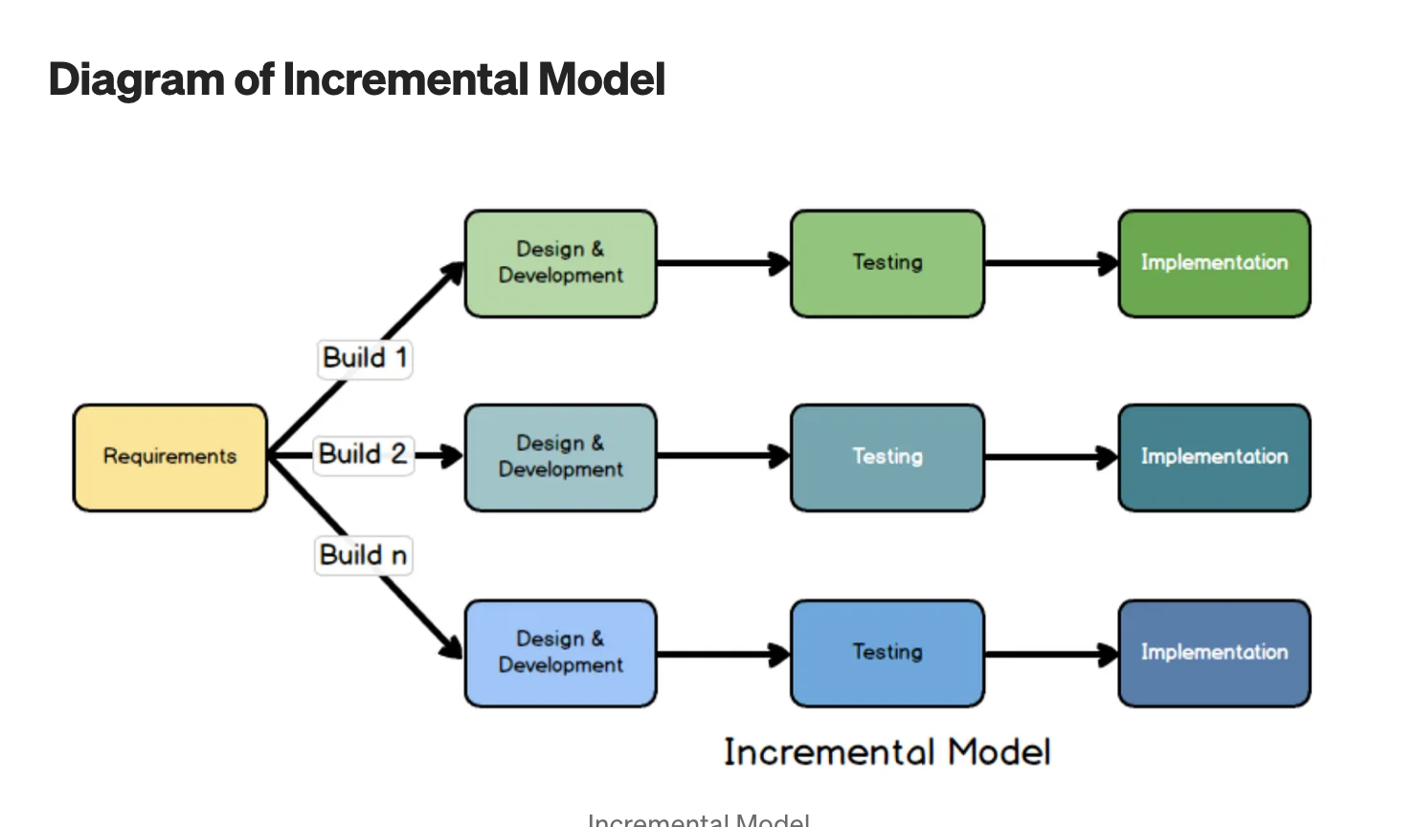
Figure 3.2: Incremental Development Model — Parallel development tracks delivering successive software versions

3.3.1 Types of Incremental Development
- Staged Delivery: Increments are planned and delivered sequentially, one after another.
- Evolutionary Delivery: Early increments are exploratory; later ones refine based on feedback.

3.3.2 Advantages of the Incremental Model
- Generates working software early in the development lifecycle
- More flexible than waterfall — easier to adapt to changing requirements
- Customers can identify requirements for later increments after seeing early ones
- Risk of project failure is reduced by delivering in manageable segments
- Easier to test and debug smaller modules in each increment

3.3.3 Disadvantages of the Incremental Model
- Requires clear initial definition of the full system to decompose into increments
- Total cost may be higher due to incremental planning overhead
- System architecture may degrade over time as increments are integrated
- Management complexity increases as multiple increments are in progress

3.4 The Spiral Model
Proposed by Barry Boehm in 1986, the Spiral Model is a risk-driven process model that combines the iterative nature of prototyping with the systematic aspects of the waterfall model. It is particularly suited for large, complex, and high-risk software systems.

The model is represented as a spiral. Each loop of the spiral represents a phase (called a cycle or iteration). As cycles complete, the spiral moves outward, building progressively more complete versions of the software.

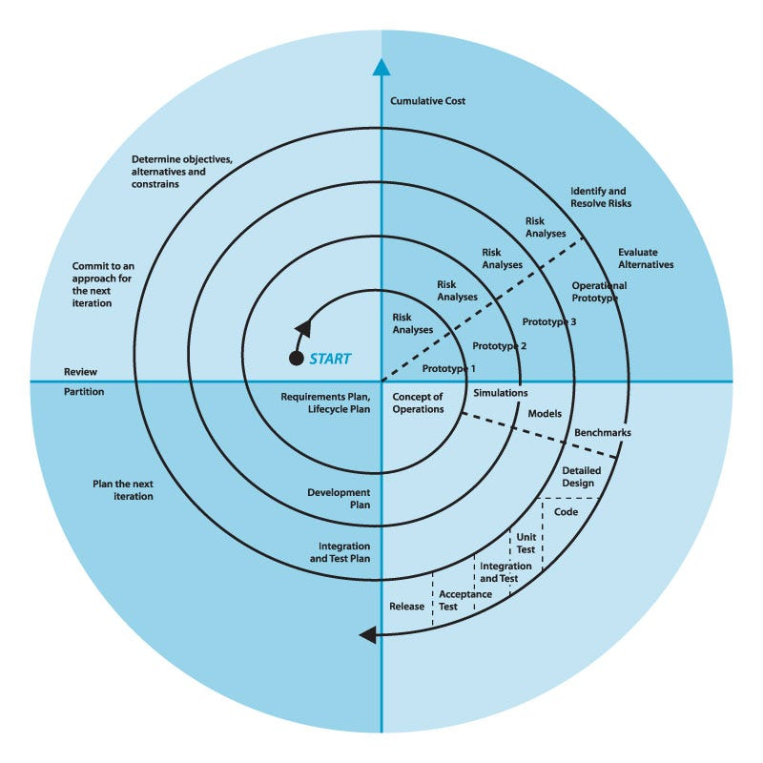
Figure 3.3: Boehm's Spiral Model — Risk-driven iterative development with four quadrant activities

3.4.1 The Four Quadrants
- Determine Objectives (Q1): Define goals, alternatives, and constraints for this iteration. Identify what you are trying to achieve.
- Identify and Resolve Risks (Q2): Identify and prioritise risks. Use prototyping, simulation, or analysis to resolve critical risks before proceeding.
- Development and Testing (Q3): Once risks are addressed, develop and verify the product for this iteration using an appropriate model.
- Plan Next Iteration (Q4): Review progress, plan for the next cycle, and commit to an approach.

3.4.2 Advantages of the Spiral Model
- Explicit risk management in every iteration reduces project failures
- Combines prototyping with systematic planning for early user feedback
- Flexible — the development approach in each cycle can vary
- Suitable for large-scale, high-risk, and mission-critical systems
- Supports change throughout the lifecycle

3.4.3 Disadvantages of the Spiral Model
- Costly and time-consuming — risk analysis requires specialist expertise
- Not suitable for small or low-risk projects
- Complex model that can be difficult to manage
- Success depends heavily on accurate risk identification and assessment

3.5 Agile Software Development
Agile is not a single process model but a philosophy of software development based on the Agile Manifesto (Beck et al., 2001). Agile methods prioritise delivering working software frequently through short iterations, close collaboration with customers, and responding to change over following a rigid plan.

The Agile Manifesto — Four Core Values
1. Individuals and interactions over processes and tools
2. Working software over comprehensive documentation
3. Customer collaboration over contract negotiation
4. Responding to change over following a plan
While there is value in the items on the right, the items on the left are valued more.

The 12 Agile Principles (derived from the manifesto) guide teams toward sustainable, customer-focused, and high-quality software development. Key principles include continuous delivery of valuable software, welcoming changing requirements, daily collaboration between business people and developers, and maintaining a constant sustainable development pace.

3.5.1 Scrum
Scrum is the most widely adopted Agile framework. Developed by Ken Schwaber and Jeff Sutherland, Scrum provides a lightweight structure for managing complex product development. Work is delivered in time-boxed iterations called Sprints.

Scrum Roles
- Product Owner: Owns and prioritises the Product Backlog; responsible for maximising the value of the product. Acts as the voice of the customer.
- Scrum Master: Facilitates the Scrum process; removes impediments; coaches the team on Agile principles. Not a traditional project manager.
- Development Team: A self-organising, cross-functional team (typically 3–9 people) responsible for delivering working software each sprint.

Scrum Artefacts
- Product Backlog: An ordered list of everything known to be needed in the product. Continuously refined and re-prioritised by the Product Owner.
- Sprint Backlog: The set of Product Backlog items selected for the current Sprint, plus a plan for delivering them.
- Increment: The sum of all Product Backlog items completed during a Sprint. Must be in a usable, potentially releasable condition.

Scrum Ceremonies (Events)
- Sprint Planning: The team selects items from the Product Backlog and plans how to complete them within the sprint. Time-boxed to 8 hours for a 4-week sprint.
- Daily Scrum (Standup): A 15-minute daily inspection where team members answer: What did I do yesterday? What will I do today? Are there any impediments?
- Sprint Review: Held at the end of the sprint; the team demonstrates the increment to stakeholders and gathers feedback.
- Sprint Retrospective: The team reflects on the past sprint — what went well, what did not, and how to improve processes in the next sprint.

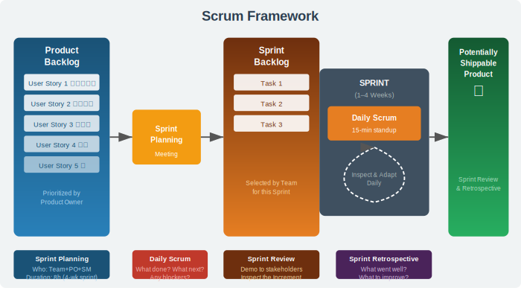
Figure 3.4: The Scrum Framework — Roles, artefacts, and ceremonies in a Sprint cycle

Sprints
A Sprint is a time-box of one month or less during which a potentially releasable product increment is created. Key characteristics:
- Fixed duration (1–4 weeks, commonly 2 weeks)
- No changes that could endanger the sprint goal are made during the sprint
- Scope may be clarified and renegotiated between the Product Owner and team
- A sprint can be cancelled if the sprint goal becomes obsolete (only by Product Owner)

3.5.2 Extreme Programming (XP)
Extreme Programming (XP), introduced by Kent Beck in 1999, is an Agile framework that focuses on engineering practices and technical excellence. It is designed to enable teams to produce high-quality software while responding rapidly to changing customer requirements.

XP is called "extreme" because it takes established software engineering best practices and applies them to extreme levels — for example, if code review is good, do it all the time (pair programming).

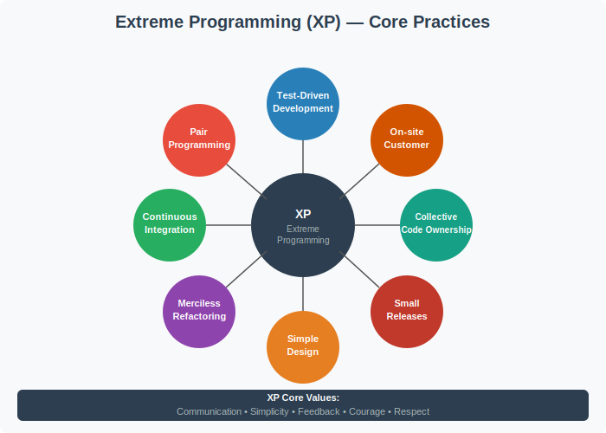
Figure 3.5: XP Core Practices — Eight engineering practices centred around XP values

XP Core Values
- Communication: All members should communicate regularly and openly
- Simplicity: Write the simplest code that works; do not over-engineer
- Feedback: Continuous feedback from tests, customers, and team members
- Courage: Make difficult decisions (e.g., refactor legacy code, discard failing experiments)
- Respect: Every team member values every other team member's contribution

XP Key Practices in Detail
- Test-Driven Development (TDD): Write automated tests before writing the production code. Red → Green → Refactor cycle ensures code correctness.
- Pair Programming: Two developers work at one machine — one writes code (Driver), the other reviews it (Navigator). Roles switch frequently. Reduces defects and improves design.
- Continuous Integration (CI): Developers integrate their code multiple times per day. Every integration is verified by automated builds and tests.
- Refactoring: Continuously improve the internal structure of the code without changing its external behaviour. Keeps the codebase clean and maintainable.
- Simple Design: Always design the simplest solution that meets current requirements. Do not add complexity for hypothetical future needs (YAGNI — You Ain't Gonna Need It).
- Small Releases: Release to production frequently — ideally daily or every few days. Reduces risk and increases feedback speed.
- Collective Code Ownership: Any developer can modify any part of the codebase at any time. Reduces knowledge silos and bus factor risk.
- On-site Customer: A real customer representative is embedded in the development team full-time to answer questions, define requirements, and provide immediate feedback.

Comparison: Scrum vs XP
Scrum is a process framework focused on project management (roles, ceremonies, artefacts). XP is an engineering methodology focused on technical practices (TDD, pair programming, CI). They are complementary — many teams use Scrum for project management with XP engineering practices. This combination is sometimes called "Scrum-XP."

3.6 Comparison of Software Process Models
No single process model is universally superior. The choice depends on project characteristics, team size, requirements stability, customer availability, and risk tolerance. The table below provides a structured comparison:

Criteria | Waterfall | Incremental | Spiral | Agile/Scrum
Requirements clarity | Fixed upfront | Partially known | Evolving, risky | Evolving
Project size | Any | Medium-Large | Large/Complex | Small-Medium
Customer involvement | Low | Moderate | Moderate | High
Risk management | Weak | Moderate | Strong | Continuous
Delivery style | Single delivery | Incremental | Iterative | Iterative sprints
Documentation | Heavy | Moderate | Heavy | Minimal
Change tolerance | Low | Moderate | Moderate | High
Best for | Stable, well-defined | Modular systems | High-risk projects | Fast-changing needs

Selecting the Right Model — Decision Guide
- Requirements are fixed and well-understood → Waterfall
- Requirements are partially known, system can be modularised → Incremental
- High-risk project with uncertainty → Spiral
- Requirements evolve rapidly, customer available → Agile (Scrum/XP)
- Highly regulated domain with documentation requirements → Waterfall or Spiral
- Small co-located team, fast delivery needed → XP
- Large team, multiple stakeholders → Scrum

Chapter 3 Summary
Software process models provide structured approaches for software development. The Waterfall model is sequential and documentation-heavy; the Incremental model delivers functionality in stages; the Spiral model adds risk management to iterative development. Agile methods, including Scrum and XP, focus on flexibility, collaboration, and rapid delivery of working software. Each model has strengths and weaknesses that must be matched to project context for optimal outcomes.

Review Questions
- Define a software process model and explain its purpose in software engineering.
- Describe the six phases of the Waterfall model and identify two scenarios where it is appropriate.
- How does the Incremental model differ from the Waterfall model? What are the key benefits of incremental delivery?
- Explain the role of risk management in the Spiral model. Why is it particularly suitable for large-scale systems?
- List and explain the four values of the Agile Manifesto. How do these values challenge traditional plan-driven approaches?
- Compare the roles of Scrum Master and Product Owner. Why is the Scrum Master NOT a project manager in the traditional sense?
- Explain how Test-Driven Development (TDD) works in XP. What is the Red-Green-Refactor cycle?
- A university wants to build a new student portal. The requirements are not fully defined, but regular student feedback is available. Recommend a suitable process model with justification.

Further Reading
- Sommerville, I. (2016). Software Engineering (10th ed.). Pearson — Chapters 2, 3
- Pressman, R. S. & Maxim, B. (2015). Software Engineering: A Practitioner's Approach (8th ed.). McGraw-Hill
- Beck, K. et al. (2001). Manifesto for Agile Software Development. agilemanifesto.org
- Schwaber, K. & Sutherland, J. (2020). The Scrum Guide. scrumguides.org
- Beck, K. (1999). Extreme Programming Explained: Embrace Change. Addison-Wesley
- Boehm, B. (1986). A Spiral Model of Software Development and Enhancement. ACM SIGSOFT

